**DAILY ONLINE ACTIVITIES SUMMARY**

|  |  |  |  |  |  |  |  |  |
| --- | --- | --- | --- | --- | --- | --- | --- | --- |
| **Date:** | | **02-07-2020** | | | | **Name:** | **Chandana Patil** | |
| **Sem & Sec** | | **6th Sem & A Sec** | | | | **USN:** | **4AL17CS020** | |
| **Online Test Summary** | | | | | | | | |
| **Subject** | | |  | | | | | |
| **Max. Marks** | | | **-** | **Score** | | | **-** | |
| **Pre-placement Training Summary** | | | | | | | | |
| **Topic** |  | | | | | | | |
| **Faculty** |  | | | | **Duration** | | |  |
| **Coding Challenges** | | | | | | | | |
| **Problem Statement**:  Two programs. | | | | | | | | |
| **Status: Solved** | | | | | | | | |
| **Uploaded the report in Github** | | | | | **yes** | | | |
| **If yes Repository name** | | | | | **https://github.com/chandanapatil/OnlineCourse2.git** | | | |
| **Uploaded the report in slack** | | | | | **yes** | | | |

**ONLINE CODING:**

**1.** Write a program that will read a sequence of positive real numbers entered by the user and will print the same numbers in sorted order from smallest to largest. The user will input a zero to mark the end of the input. Assume that at most 100 positive numbers will be entered.

import java.util.Scanner;

public class Demo {

public static void main(String[] args)

{

int number;

Scanner scan = new Scanner(System.in);

System.out.print("Enter the number you want to check:");

number = scan.nextInt();

scan.close();

if(number > 0)

{

System.out.println(number+" is positive number");

}

else if(number < 0)

{

System.out.println(number+" is negative number");

}

else

{

System.out.println(number+" is neither positive nor negative");

}

}

}

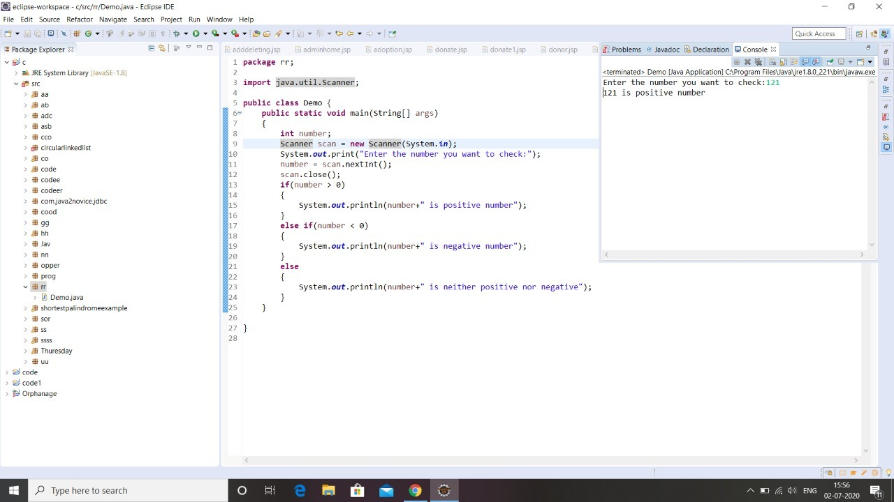

**2. Python Program to Create a Class in which One Method Accepts a String from the User and Another Prints its**

class print1():

def __init__(self):

self.string=""

def get(self):

self.string=input("Enter string: ")

def put(self):

print("String is:")

print(self.string)

obj=print1()

obj.get()

obj.put()

